How to upload a video to YouTube to share with students

Why would I want to do this?
- To share with your students an instructional video you created

Steps to creating a You Tube account
- Go to www.youtube.com
- Click the large blue "Create Account" button, or the smaller link with the same name at the top right of the page.
- Fill out the form with your personal information. If you have a Gmail address, entering it as your email address in this form will save you time later. When you're done filling out the form, click the "I Accept" button.
- If you used your Gmail account when creating your YouTube account, you'll be asked to link them together on the next page. If this is the case, link the accounts. If you did not use your Gmail account (because you don't have one) you'll be asked to create one on the next page. If this is the case, create a Gmail account and it will be linked to your new YouTube account.
- Now you're signed up and should be automatically signed in. You'll know if you're signed in if you see your YouTube account name in the upper right corner of the screen. If you don't, you should see a "Sign In" link up there. Click that, then sign in with your new YouTube username and password.

Steps for uploading a video
- Make sure you're signed into your account by looking up at the top right hand part of the page. If you see your username, you're signed in.
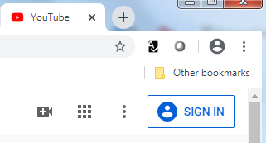
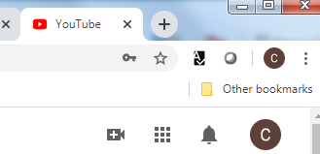

- To the left of your username, you'll find a link called "Create a video and more." Click on this icon then choose Upload Video.
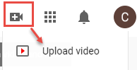
- Once you've clicked the "Upload video" button, you'll see a new window pop up that will let you select a file that you have saved on your computer. Select the video you want to upload and click the "Choose" button.
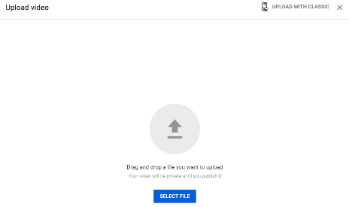

- The video will start to upload and you'll see its progress as well as a bunch of other options. Make sure you do not close this page until the video has finished uploading or it will not finish. While the video is uploading you can change the name, add a description, and fill out other relevant information.
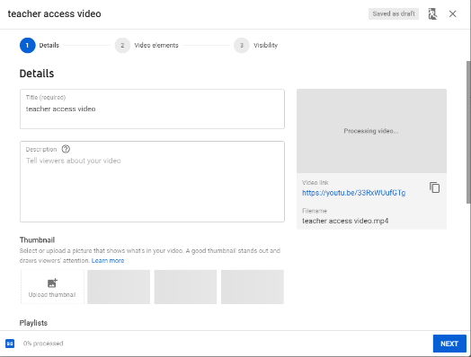

- Once the video has finished uploading click the Next button to continue. The Video Elements screen will display.
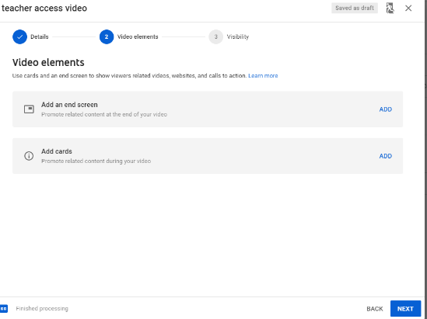

- Click Next to continue. The Visibility screen will display. This is the time to decide who can see your video. Each option is described below.
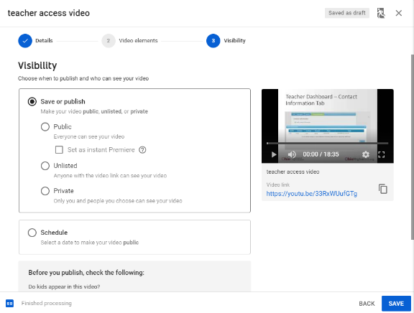

- Click Save to publish your video.
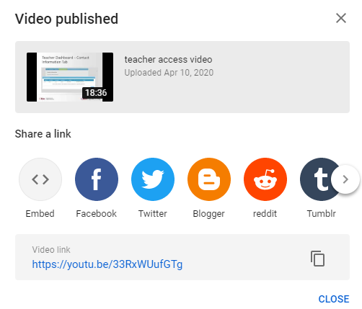
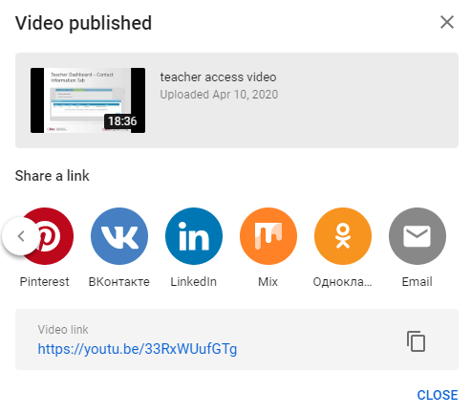

- When you're on your video's page, you'll be able to watch it and share it. Below the video is a section labeled "Share a link" that will provide you with a link to send to other people and several sharing options, such as email and Facebook. Use the scroll arrow to see additional options.
- Alternatively, you can always find your videos by clicking on your username at the top left of the page and then choosing "Videos" (which may be labeled as "My Videos" for some accounts). This will let you access all the videos you have uploaded.

Privacy options in YouTube
PUBLIC
This is the default setting for all YouTube videos. Anyone can search for, view, or share a public video.

Unlisted
This video setting is somewhat of a cross between private and public. Unlisted videos are invisible in search results, subscriber feeds, suggestions, and user video tabs. However, with unlisted videos, anyone with the link can see and share your video.

Private
The most secure type of video on YouTube. They are only visible to people (up to 50 in total) that you invite. Private videos don’t appear in video recommendations, search results, and video tab sections for uploading.
Plus, invitees can’t share the video with other people. Also, even if someone has the link, they still can’t see your video unless they have the invite.

https://www.youtube.com/watch?v=XwkL9_ESjcU

